**Java Assignment 1**

**Introduction**

I am aiming to design a weather bar graph that displays the average weather year-round. This project will consist of a title graph, ranges of values to join, and a set of labels and values to be shown in the bar graph. I will create criteria where the user cannot enter values outside the range, and I will display each value or point when the user enters the values.

**User Values**

*\*Including an invalided value (outside of range)*

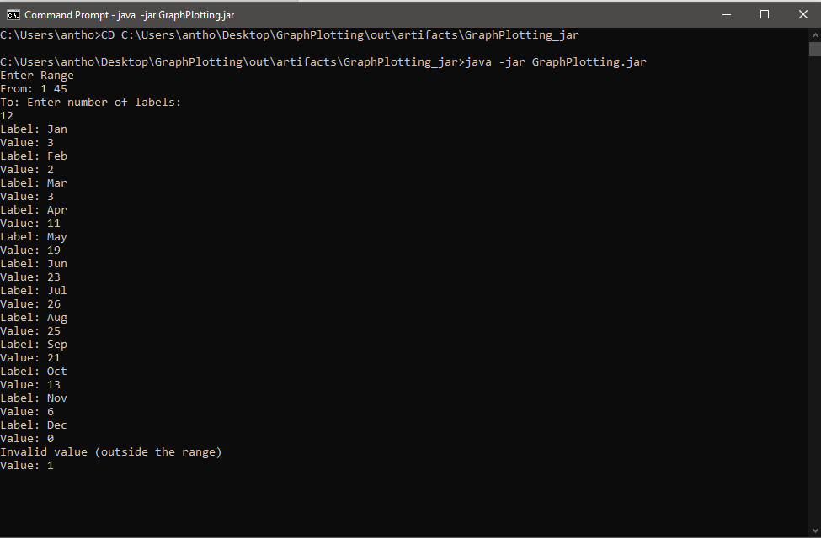

**Values Graphed**

